**CSC420 Assignment3**

**Student name: Yilin Qu**

**Student number: 1002995734**

**Utorid: quyilin**

**Part A**

**import** numpy **as** np  
**import** matplotlib  
matplotlib.use('TkAgg')  
**import** matplotlib.pyplot **as** plt  
**import** cv2 **as** cv  
  
img = cv.imread("door.jpg")  
plt.imshow(img, cmap="gray")  
plt.show()  
  
# plot four corners on the door  
x1, y1 = 671.5, 320.7  
x3, y3 = 769.8, 3625.68  
x2, y2 = 1904.13, 112.95  
x4, y4 = 1926.05, 3952.95  
  
M, N = img.shape[0], img.shape[1]

x_1, y_1 = 0, 0  
x_2, y_2 = M-1, 0  
x_3, y_3 = 0, N-1  
x_4, y_4 = M-1, N-1  
  
img = cv.imread("door.jpg")  
  
A = np.array([[x1, y1, 1, 0, 0, 0, -x_1 * x1, -x_1 * y1, -x_1],  
 [0, 0, 0, x1, y1, 1, -y_1 * x1, -y_1 * y1, -y_1],  
  
 [x2, y2, 1, 0, 0, 0, -x_2 * x2, -x_2 * y2, -x_2],  
 [0, 0, 0, x2, y2, 1, -y_2 * x2, -y_2 * y2, -y_2],  
  
 [x3, y3, 1, 0, 0, 0, -x_3 * x3, -x_3 * y3, -x_3],  
 [0, 0, 0, x3, y3, 1, -y_3 * x3, -y_3 * y3, -y_3],  
  
 [x4, y4, 1, 0, 0, 0, -x_4 * x4, -x_4 * y4, -x_4],  
 [0, 0, 0, x4, y4, 1, -y_4 * x4, -y_4 * y4, -y_4]])  
  
# use numpy method to get h  
  
ATA = np.matmul(A.T, A)  
eigenvalues, eigenvector = np.linalg.eig(ATA)  
h = eigenvector[:, np.argmin(eigenvalues)]  
H = h.reshape((3, 3))  
  
img1 = cv.warpPerspective(img, H, (5000, 4000))  
  
plt.imshow(img1), plt.show()

**Idea:**

Stick the paper on the door and make the horizontal and vertical edges between the paper and the door parallel.

First we find four corners of the **door** on our captured image, and use these four points as the parameters to get the projective image. To get **h,** I first pass in four pairs of points so that I can solve the matrix equation to get h11-h22, and then us this **h** matrix to perform a warp operation. Then on the projective image, find four corner points of the paper and four corner points of the door, then calculate relative pixel-distance horizontal and vertical distance. Since we know the **actual size of paper** as well as the **ratio** of the pixel-distance between the paper and the door, we can use these two numbers to calculate the **actual size of the door.**, since homography does not change the ratio between parallel lines.

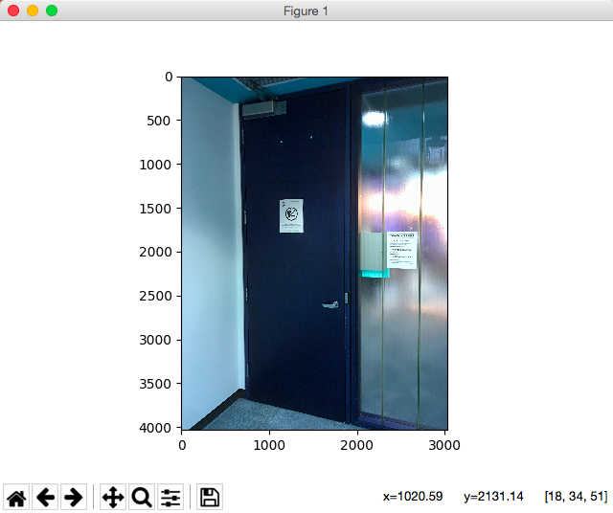 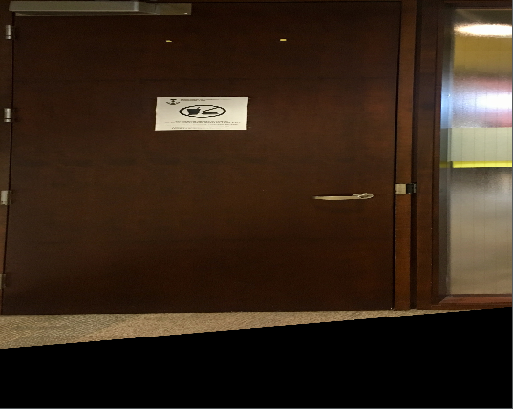

The left image is the picture captured at first, the right image is the image after homography. The parameters are as follows:

* **top left corner of the door: 248.418, 252.747**
* **bot left corner of the door: 248.418, 3099.07**
* **top right corner of the door: 3917.25, 252.747**
* **bot right corner of the door: 3917.25, 3099.07**
* **top left corner of the paper: 1590.41, 1042.79**
* **bot left corner of the paper: 1590.41, 1345.82**
* **top right corner of the paper: 2477.85, 1042.79**
* **bot right corner of the paper: 2477.85, 1345.82**

Using these data, we can calculate:

**height of the door** is:

279.4mm * (3099.07 – 252.747) / (1345.82 – 1042.79) =**2624.36936 mm**

**width of the door** is:

215.9mm * (3917.25 – 248.418) / (2477.85 – 1590.41) = **892.5683 mm**

**Part B**

**(a)**

**open source from:**

# open source implementation and modification from following link:  
# https://docs.opencv.org/3.0-beta/doc/py_tutorials/py_feature2d/py_feature_homography/py_feature_homography.html

**def find_match**(threshold):  
 MIN_MATCH_COUNT = 200  
 img2 = cv.imread('whitebook.jpg') # queryImage  
 img1 = cv.imread('cover.jpg') # trainImage  
 # img1 = cv2.imread('img2.jpg', 0) # trainImage  
 # img1 = cv2.imread('img3.jpg',0) # trainImage  
 # Initiate SIFT detector  
 sift = cv.xfeatures2d_SIFT.create()  
 # find the keypoints and descriptors with SIFT  
 kp1, des1 = sift.detectAndCompute(img1,**None**)  
 kp2, des2 = sift.detectAndCompute(img2,**None**)  
 FLANN_INDEX_KDTREE = 0  
 index_params = dict(algorithm = FLANN_INDEX_KDTREE, trees = 5)  
 search_params = dict(checks = 50)  
 flann = cv.FlannBasedMatcher(index_params, search_params)  
 matches = flann.knnMatch(des1,des2,k=2)  
 # store all the good matches as per Lowe's ratio test.  
 good = []  
 **for** m,n **in** matches:  
 **if** m.distance < threshold*n.distance:  
 good.append(m)  
 draw_params = dict(matchColor = (0,255,0), singlePointColor = **None**, flags = 2)  
 img3 = cv.drawMatches(img1,kp1,img2,kp2,good,**None**,**draw_params)  
 cv.imwrite("q2_a.jpg", img3)  
 # plt.imshow(img3), plt.show()  
 **return** kp1, kp2, good

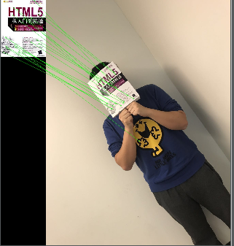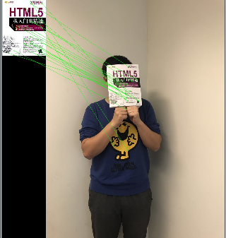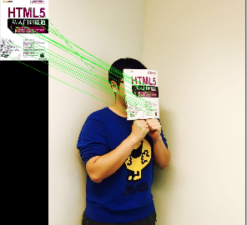

img1 img2 img3

**Use the random 20 matches here:**

outlier = 4 / 20 6 / 20 10 / 20

**Use top 20 matchs:**

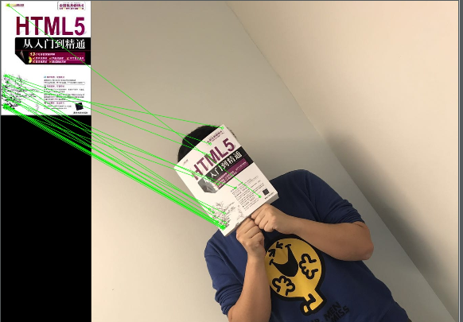 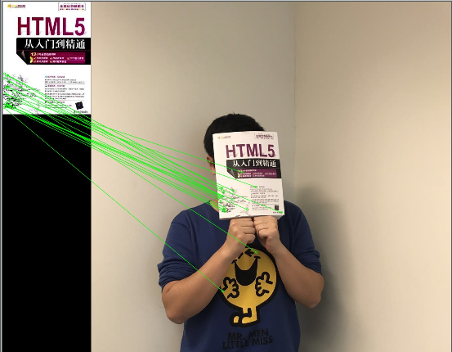 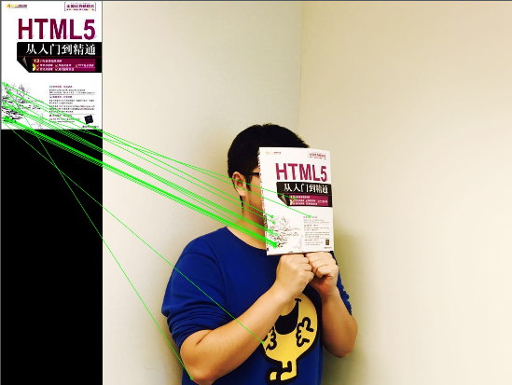

outlier = 2 / 20 2 / 20 4 / 20

**Use all matches:**

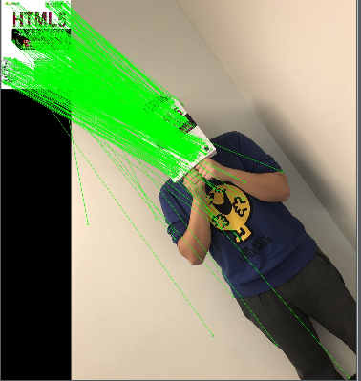 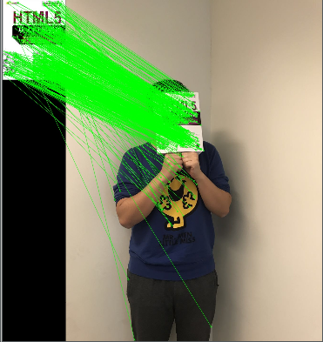 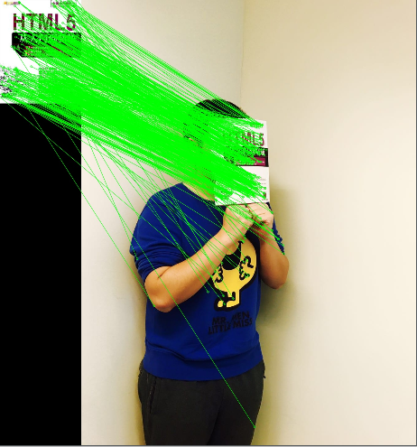

outlier = (esitimated)

70 / 623 90 / 606 100 / 556

(Some of the matches are right on the book but the relative positions do not match, so I count them as outliers as well)

**(b)**

**def Q2_b_affine**(P, p):  
 **return** (np.log(1 - P)) / (np.log(1 - pow(p, 3)))  
  
**def Q2_b_homography**(P, p):  
 **return** (np.log(1 - P)) / (np.log(1 - pow(p, 4)))

**Use the result computed from “random 20 samples”**.

Here P is 0.99, p is the visually estimated rate of inliers, and in affine transformation we need at least 3 pairs of keypoints, while in homography we need at least 4 pairs(according to the derivation of the transformation matrix).

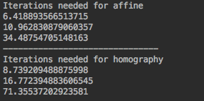

**Use top 20 matches:**

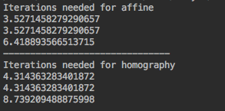

Result will be significantly improved. Since the inlier rate is high enough.

**(c) and (d)**

**def ransac_transformation**(mode, img1, img2, outimage):  
 kp1, kp2, good = find_match(img2, 0.55)  
  
 img2 = cv.imread(img2) # queryImage  
 img1 = cv.imread(img1) # trainImage  
  
 src = np.array([kp1[m.queryIdx].pt **for** m **in** good])  
 dst = np.array([kp2[m.trainIdx].pt **for** m **in** good])  
 **if** mode == "affine":  
 model_robust, inliers = sk.measure.ransac((src, dst), AffineTransform, min_samples=5, residual_threshold=2,  
 max_trials=100)  
 h = model_robust.params  
 np.delete(h, 2, axis=0)  
 **for** i **in** range(img1.shape[0]):  
 **for** j **in** range(img1.shape[1]):  
 src = np.array([[j],  
 [i],  
 [1]])  
 dst = np.matmul(h, src)  
  
 y = int(dst[0, 0])  
 x = int(dst[1, 0])  
  
 img2[x, y] = img1[i, j]  
 cv.imwrite(outimage, img2)  
  
 **elif** mode == "homography":  
 model_robust, inliers = sk.measure.ransac((src, dst), ProjectiveTransform, min_samples=5, residual_threshold=2,  
 max_trials=100)  
 h = model_robust.params  
 **for** i **in** range(img1.shape[0]):  
 **for** j **in** range(img1.shape[1]):  
 src = np.array([[j],  
 [i],  
 [1]])  
 dst = np.matmul(h, src)  
  
 y = int((dst[0, 0] / dst[2, 0]))  
 x = int((dst[1, 0] / dst[2, 0]))  
  
 img2[x, y] = img1[i, j]  
 cv.imwrite(outimage, img2)  
 **else**:  
 **return False**

**Mode == “affine”:**



**Mode == “homography”:**

****In practice my algorithm will fail when:

* **I change the parameter “min_sample” to be less than 3 for affine or less than 4 for homography**
* **Sometimes there might be some “NaN” values so I cannot round them**
* **When I try some other images, it will fail when there are some other “corners” or “edges”, for example when I put the book near a black board, the corners and edges of the black board will do affect the matches, so that cannot recover a good transformation.**
* **In the above case, sometimes RANSAC will cause the index to be out of bound, which is also a failure mode due to an incorrect matrix.**
* **I change the lighting condition too much, when it is too dark or too bright.**
* **If I warp the book too much then affine will not be accurate.**

It will success when:

* **I tried more samples(i.e., 8 or 10) on ransac for both affine and homography.**
* **I adjusted the matching threshold to be around 0.75-0.8**

Comparing affine and homography:

* **Affine needs at least 3 samples while homography needs 4**
* **Affine works better on the object with parallel edges**
* **Homography can deal with projective transforms.**
* **If I warp the book a bit, affine will have some artifacts.**
* **Affine transformation will preserve the planar property.**
* **Homography will map a projective plane.**
* **In the above results homography are more accurate than affine.**

**(e)**

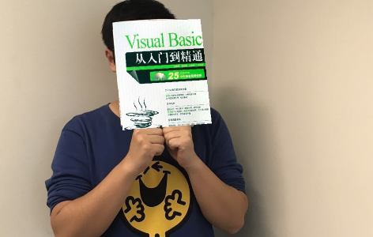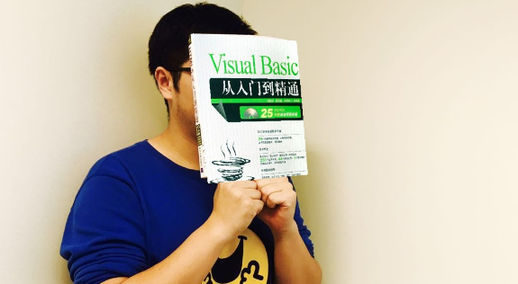

This looks a little bit wired because the size of another book cover is not perfectly the same as the previous book cover. Also, different keypoints should be detected. The positions for the book are mapped almost correctly since this two books belong to the same series, so the most of keypoints will be similar, except for the part where these two books are of different colours.

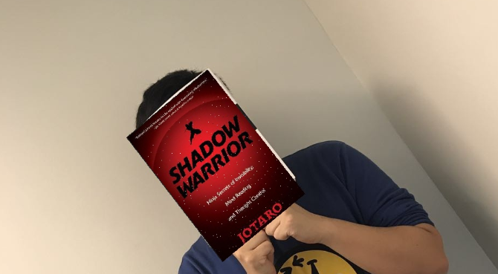

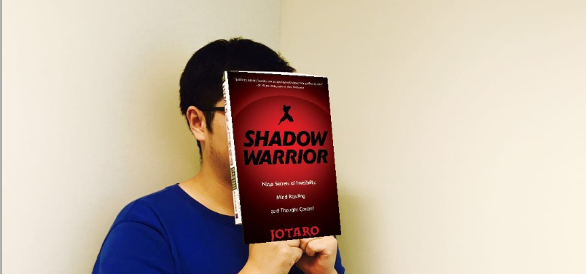

When I tried another book cover, which is a totally different book, the match looks more wired, but the corners are matched almost correct since the most perfect keypoints are their corners and edges.

**Part C**

**Method1**: camera calibration.

Taking a picture in a fixed length(d = 50cm) without out-of-plane rotation and record six different in our real-world coordinates, and then pass these six points to a matrix A, then find the null-space of A and compute the q-r factorization to find K. **(But this is probably wrong because it does not give the correct K matrix, another method is below:)**

**def find_K_2d_to_3d**():  
 img = cv.imread("q3.jpg")  
 plt.imshow(img), plt.show()  
 M, N = img.shape[0], img.shape[1]  
 x1, y1, X1, Y1, Z1 = 79.75, 281.57, -150 / M, 120 / N, 500  
 x2, y2, X2, Y2, Z2 = 114.8, 565.9, -150 / M, 0, 500  
 x3, y3, X3, Y3, Z3 = 149.9, 854.3, -150 / M, -120 / N, 500  
 x4, y4, X4, Y4, Z4 = 527.8, 262.1, 0, 120 / N, 500  
 x5, y5, X5, Y5, Z5 = 531.7, 581.5, 0, 0, 500  
 x6, y6, X6, Y6, Z6 = 539.5, 854.3, 0, -120 / N, 500  
  
 A = np.array([[X1, Y1, Z1, 1, 0, 0, 0, 0, -x1*X1, -x1*Y1, -x1*Z1, -x1],  
 [0, 0, 0, 0, X1, Y1, Z1, 1, -y1*X1, -y1*Y1, -y1*Z1, -y1],  
  
 [X2, Y2, Z2, 1, 0, 0, 0, 0, -x2 * X2, -x2 * Y2, -x2 * Z2, -x2],  
 [0, 0, 0, 0, X2, Y2, Z2, 1, -y2 * X2, -y2 * Y2, -y2 * Z2, -y2],  
  
 [X3, Y3, Z3, 1, 0, 0, 0, 0, -x3 * X3, -x3 * Y3, -x3 * Z3, -x3],  
 [0, 0, 0, 0, X3, Y3, Z3, 1, -y3 * X3, -y3 * Y3, -y3 * Z3, -y3],  
  
 [X4, Y4, Z4, 1, 0, 0, 0, 0, -x4 * X4, -x4 * Y4, -x4 * Z4, -x4],  
 [0, 0, 0, 0, X4, Y4, Z4, 1, -y4 * X4, -y4 * Y4, -y4 * Z4, -y4],  
  
 [X5, Y5, Z5, 1, 0, 0, 0, 0, -x5 * X5, -x5 * Y5, -x5 * Z5, -x5],  
 [0, 0, 0, 0, X5, Y5, Z5, 1, -y5 * X5, -y5 * Y5, -y5 * Z5, -y5],  
  
 [X6, Y6, Z6, 1, 0, 0, 0, 0, -x6 * X6, -x6 * Y6, -x6 * Z6, -x6],  
 [0, 0, 0, 0, X6, Y6, Z6, 1, -y6 * X6, -y6 * Y6, -y6 * Z6, -y6]])  
  
 ATA = np.matmul(A.transpose(), A)  
 v = np.linalg.svd(ATA)[2].T[-1].reshape((3, 4))  
 v = v[0:3, 0:3]  
 result = np.linalg.qr(v)[1]  
 print(result)

**Method2** : Using “vanishing point” method, find 3 vanishing points and record the coordinates. Here I zoom in the image and show its 3 vanishing points. They are the cross points of each two green lines.

**Derivations:**

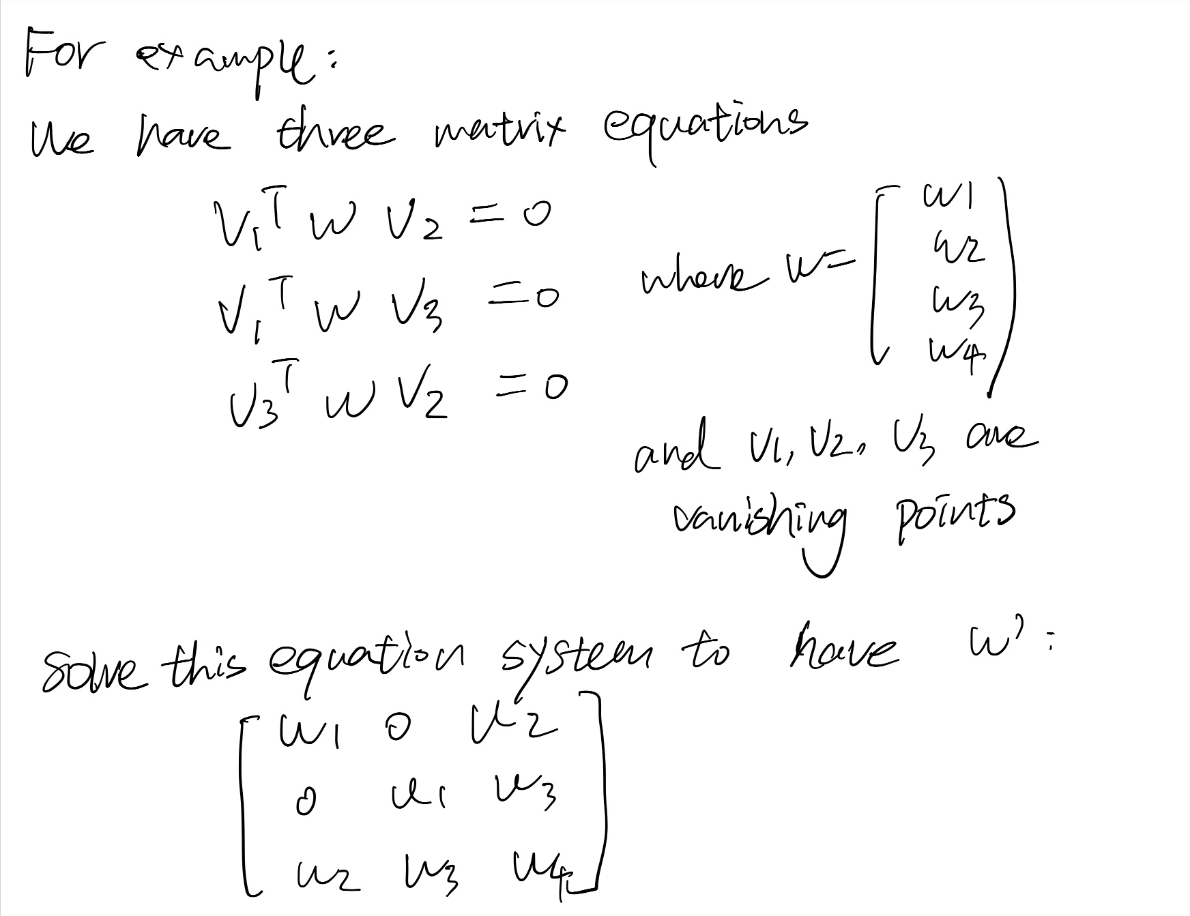

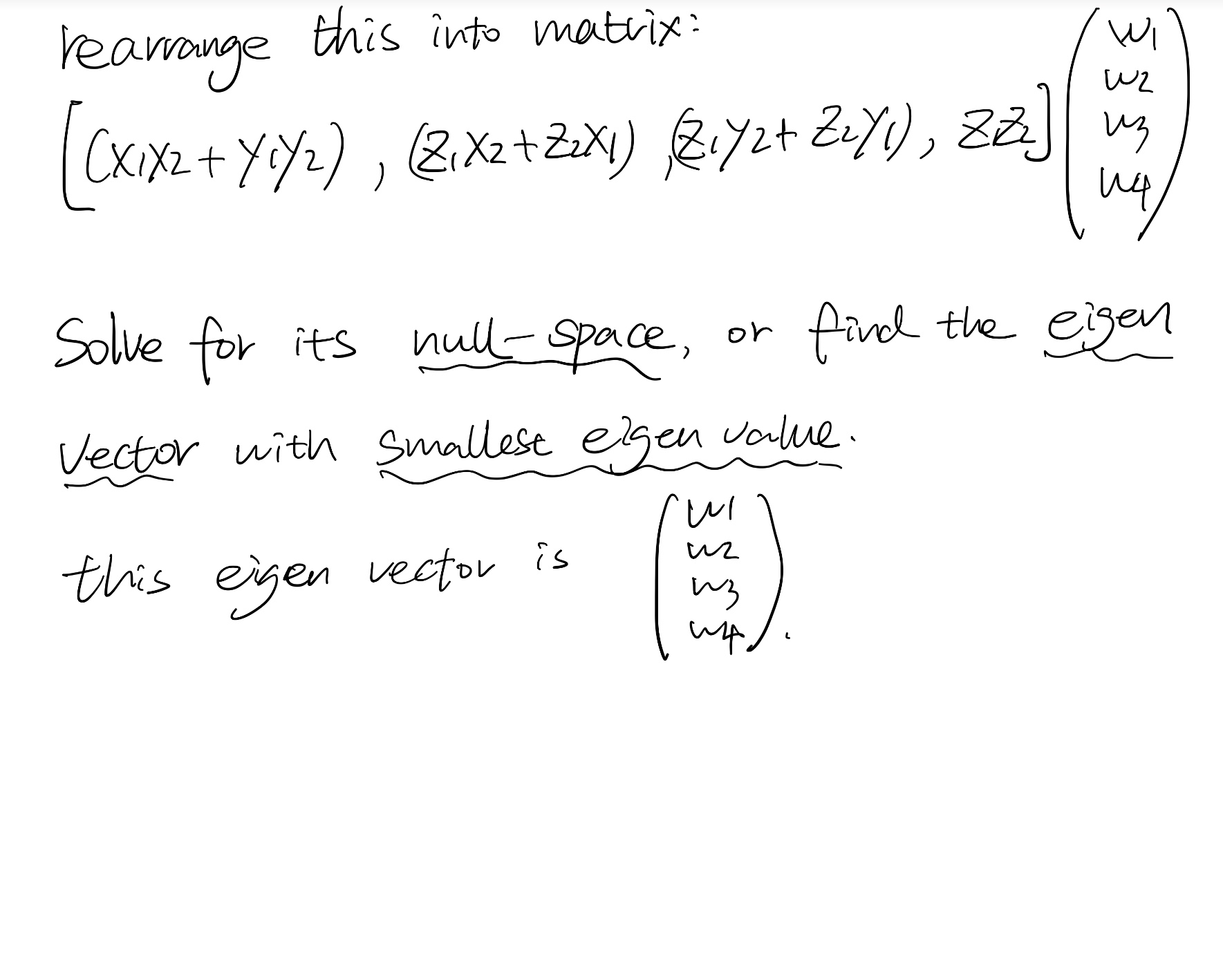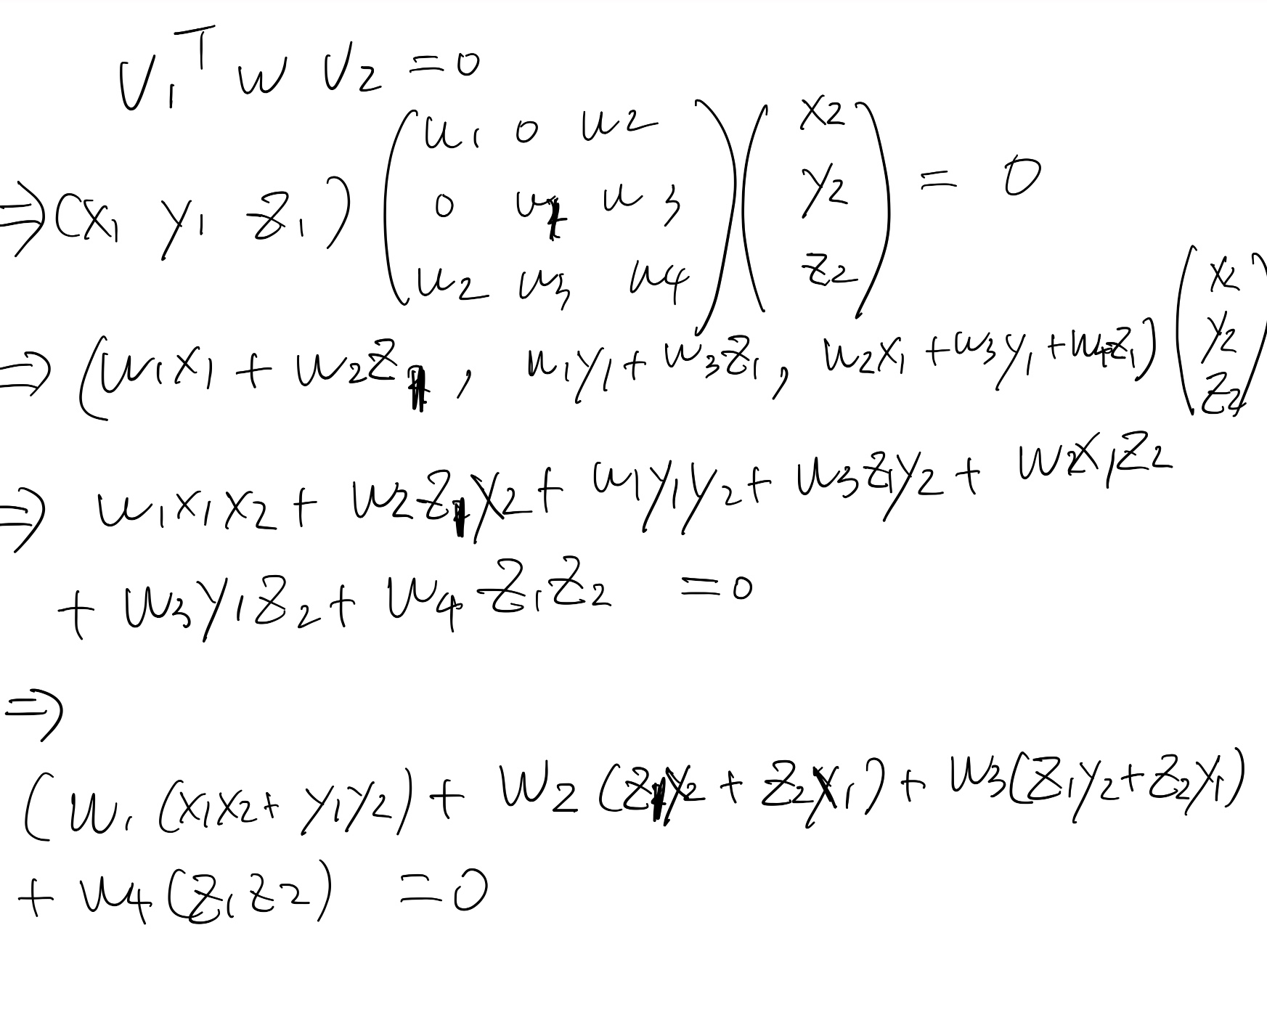

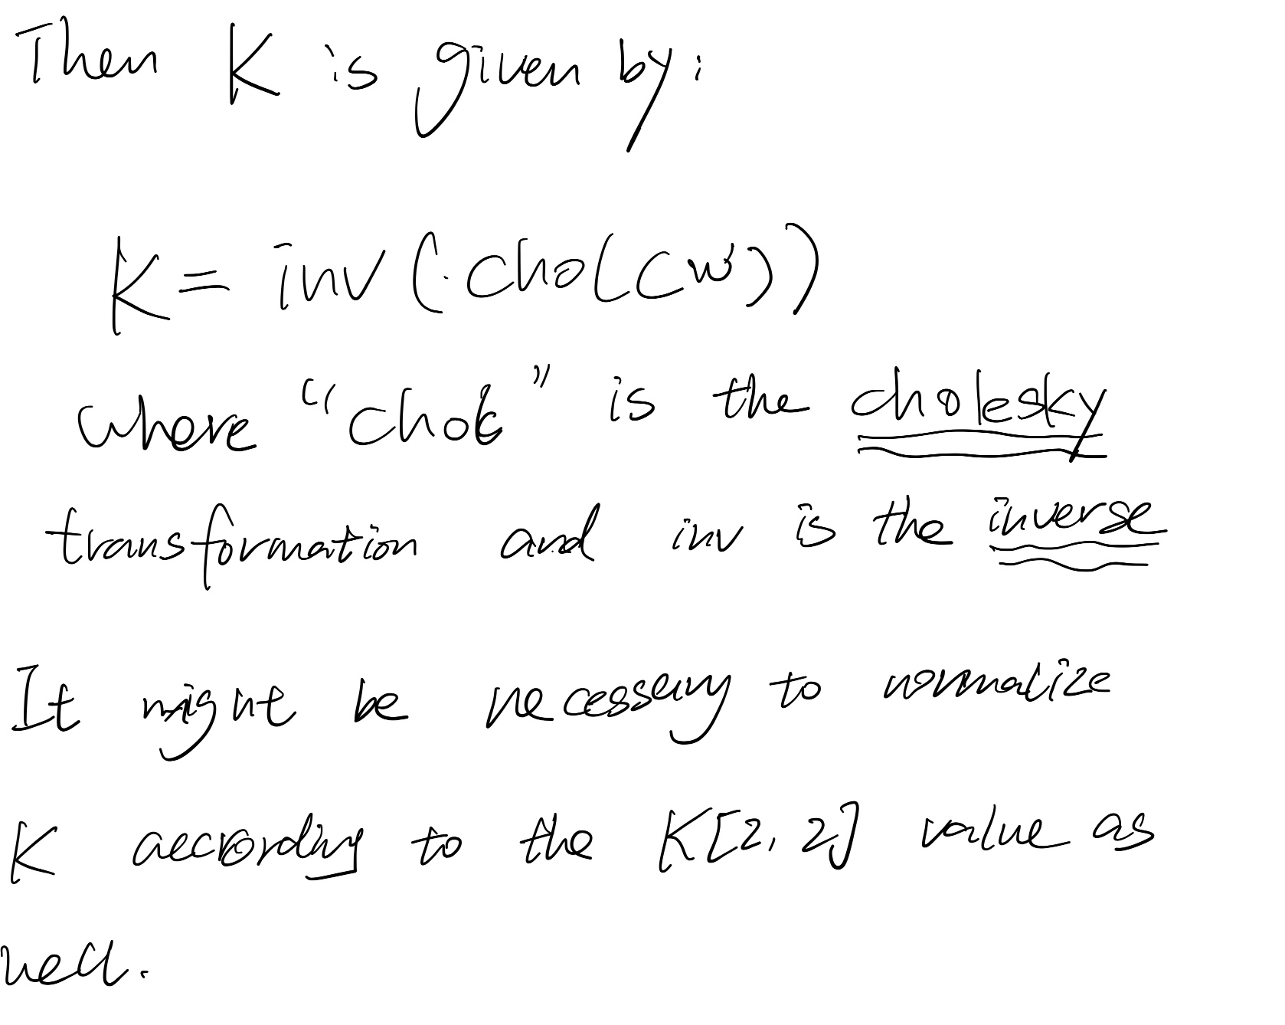

**More detailed algorithms are from this book:**

**Multiple View Geometry in Computer Vision (Page 226)**

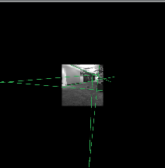

**def** find_K_vanishing_point():  
 img = cv.imread("vanishingPoint.jpg")  
 plt.imshow(img), plt.show()  
 originx, originy = 755.794, 759.24  
 x1, y1, z1 = 79.364 - originx, 962.338 - originy, 1  
 x2, y2, z2 = 1253.1 - originx, 921.516 - originy, 1  
 x3, y3, z3 = 1079.49 - originx, 1986.65 - originy, 1  
  
 # x1, y1, z1 = 212, 2138, 1  
 # x2, y2, z2 = -49, 42, 1  
 # x3, y3, z3 = 1105, 146, 1  
  
 A = np.array([[x1*x2 + y1*y2, x2*z1 + x1*z2, z1*y2 + y1*z2, z1*z2],  
 [x1*x3 + y1*y3, x3*z1 + x1*z3, z3*y1 + y3*z1, z1*z3],  
 [x2*x3 + y2*y3, x3*z2 + x2*z3, z2*y3 + z3*y2, z2*z3]])  
 # print(A)  
 ATA = np.matmul(A.T, A)  
 #print(ATA)  
 # find null space of A  
 eigenvalues, eigenvector = np.linalg.eig(ATA)  
 h = eigenvector[:, np.argmin(eigenvalues)]  
 # print(h)  
 h = np.linalg.svd(A)[2][-1]  
 #print(h)  
 w1 = h[0]  
 w2 = h[1]  
 w3 = h[2]  
 w4 = h[3]  
  
 #print(w1, w2, w3, w4)  
 w = np.array([[w1, 0, w2],  
 [0, w1, w3],  
 [w2, w3, w4]])  
 # print(w)  
 # K = inv(chol(W))  
 K = np.linalg.inv(np.linalg.cholesky(w).T)  
  
 print(K / K[2, 2])

And the K matrix I got for iPhone7 is as follows:



**Part D**

**Before blending:**

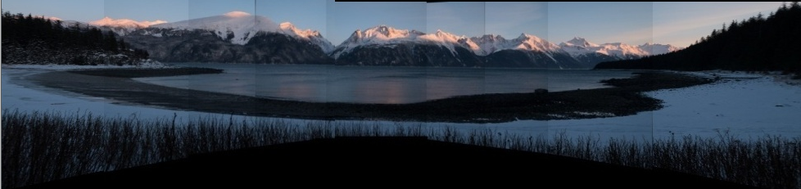

**Code:**

**import** numpy **as** np  
**import** imutils  
**import** cv2  
**import** matplotlib  
matplotlib.use('TkAgg')  
**from** matplotlib **import** pyplot **as** plt  
  
**class Stitcher**:  
 **def** __init__(self):  
 # determine if we are using OpenCV v3.X  
 self.isv3 = imutils.is_cv3()  
  
  
 **def stitch**(self, images, ratio=0.75, reprojThresh=4.0,  
 showMatches=**False**, offset=0):  
 # unpack the images, then detect keypoints and extract  
 # local invariant descriptors from them  
 (imageB, imageA) = images  
 (kpsA, featuresA) = self.detectAndDescribe(imageA)  
 (kpsB, featuresB) = self.detectAndDescribe(imageB)  
  
 # match features between the two images  
 M = self.matchKeypoints(kpsA, kpsB,  
 featuresA, featuresB, ratio, reprojThresh)  
 # if the match is None, then there aren't enough matched  
 # keypoints to create a panorama  
 **if** M **is None**:  
 **return None** (matches, H, status) = M  
 result = cv2.warpPerspective(imageA, H,  
 (imageA.shape[1] + imageB.shape[1], imageA.shape[0]))  
 result[0:imageB.shape[0], 0:imageB.shape[1]] = imageB  
 **return** result  
  
 **def detectAndDescribe**(self, image):  
 # convert the image to grayscale  
 descriptor = cv2.xfeatures2d.SIFT_create()  
 (kps, features) = descriptor.detectAndCompute(image, **None**)  
 kps = np.float32([kp.pt **for** kp **in** kps])  
 # return a tuple of keypoints and features  
 **return** (kps, features)  
  
 **def matchKeypoints**(self, kpsA, kpsB, featuresA, featuresB,  
 ratio, reprojThresh):  
 matcher = cv2.DescriptorMatcher_create("BruteForce")  
 rawMatches = matcher.knnMatch(featuresA, featuresB, 2)  
 matches = []  
 **for** m **in** rawMatches:  
 **if** len(m) == 2 **and** m[0].distance < m[1].distance * ratio:  
 matches.append((m[0].trainIdx, m[0].queryIdx))  
 ptsA = np.float32([kpsA[i] **for** (_, i) **in** matches])  
 ptsB = np.float32([kpsB[i] **for** (i, _) **in** matches])  
 # compute the homography between the two sets of points  
 (H, status) = cv2.findHomography(ptsA, ptsB, cv2.RANSAC,  
 reprojThresh)  
 **return** (matches, H, status)  
  
**def stich**(img1, img2, offset=0, flip=np.fliplr, order=**False**):  
 imageA = cv2.imread(img1)  
 imageB = cv2.imread(img2)  
 outimage = img1 + img2  
 imageA = imutils.resize(imageA, width=400)  
 imageB = imutils.resize(imageB, width=400)  
 **if** order:  
 imageA = np.fliplr(imageA)  
 imageB = np.fliplr(imageB)  
 # stitch the images together to create a panorama  
 stitcher = Stitcher()  
 (result) = stitcher.stitch([imageA, imageB], showMatches=**False**)  
 **if** flip:  
 result = flip(result)  
 cv2.imwrite(outimage, result)  
 **return** outimage

The main function contains many hard-code works that remove the dark gap between each image, and here is the main panorama stiching class.

**Describe of the procedure of creating panorama:**

**#Step1:**

Find keypoints and descriptors in each image, using the SIFT detector to detect keypoints and descriptors.

**#Step2**

Match the keypoints in each image.

**#Step3**

Find the homography estimation of two images and optimize the result using RANSAC method.

**#Step4**

Warp the image by the homography estimation matrix and calling cv2.warpPerspective to apply homography transformation.